**SECTION – 4**

**GIT REMOTING**

**SECTION-4 (Pushing source code to remote repository using Eclipse GIT plugin) - Steps to follow:**

1. One developer from project team will create eclipse projects 'Sample Proj' & add sample source code files. Then commit all files through eclipse GIT plugin.

2. Collaborate other team members with your github account so that they can also modify the committed files.

3.Other developers from same team will checkout all files from remote repository. This might get conflicts since certain files fail to merge. In such case, merge it manually.

4. Commit & push the "Sample Proj" project.

**Eclipse Sample Project Creation and performing the First Commit:**

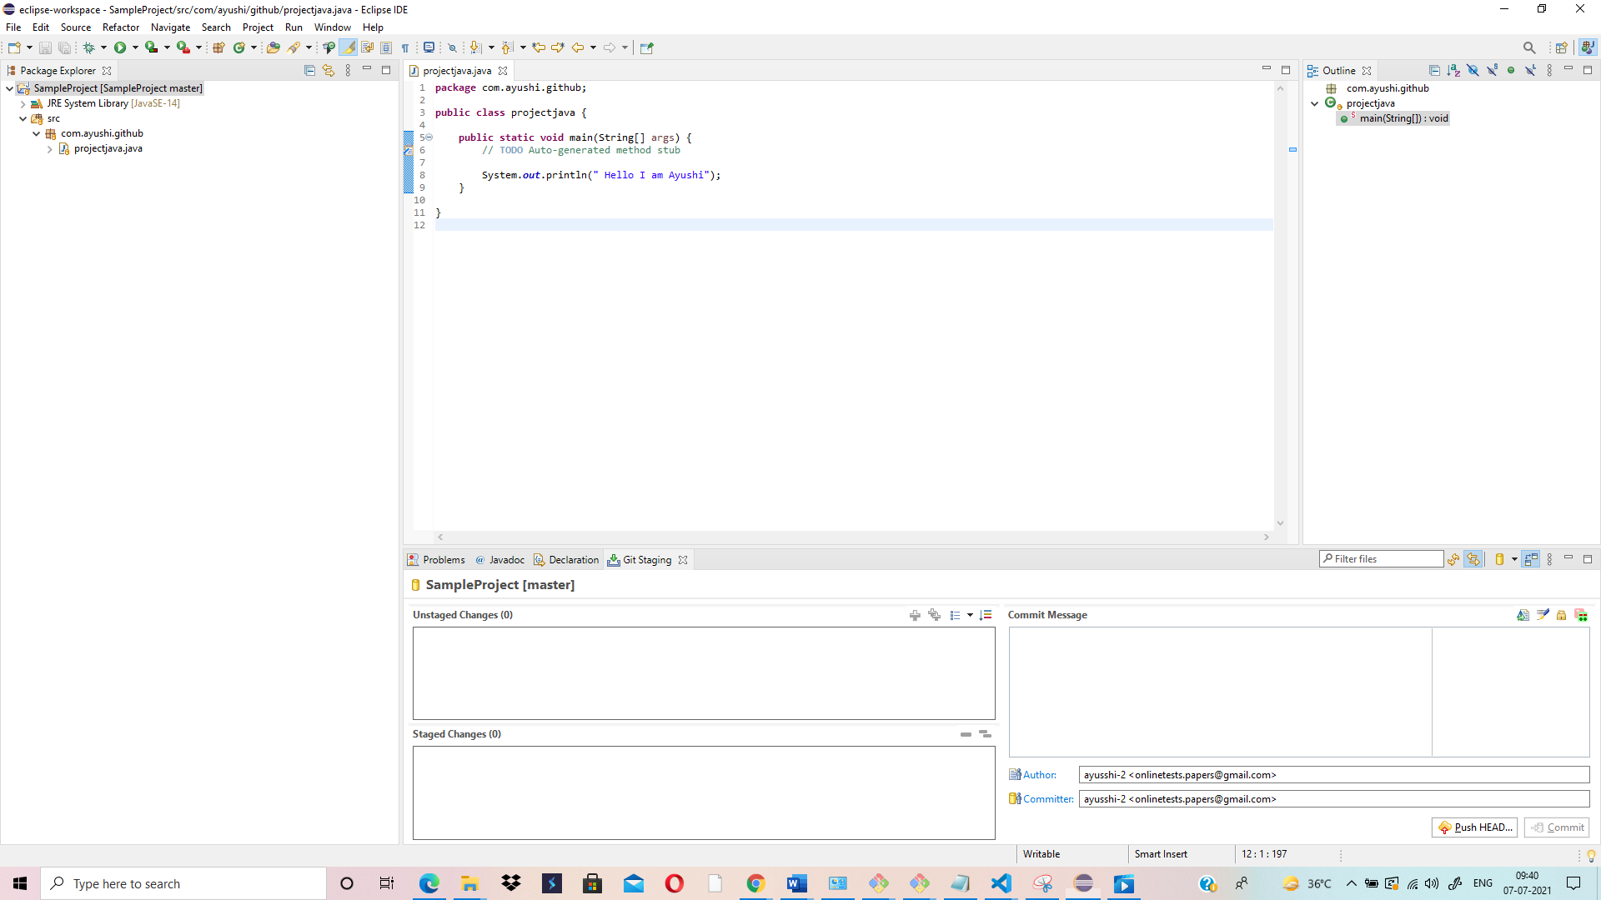

**Shows commit in Master Branch:**

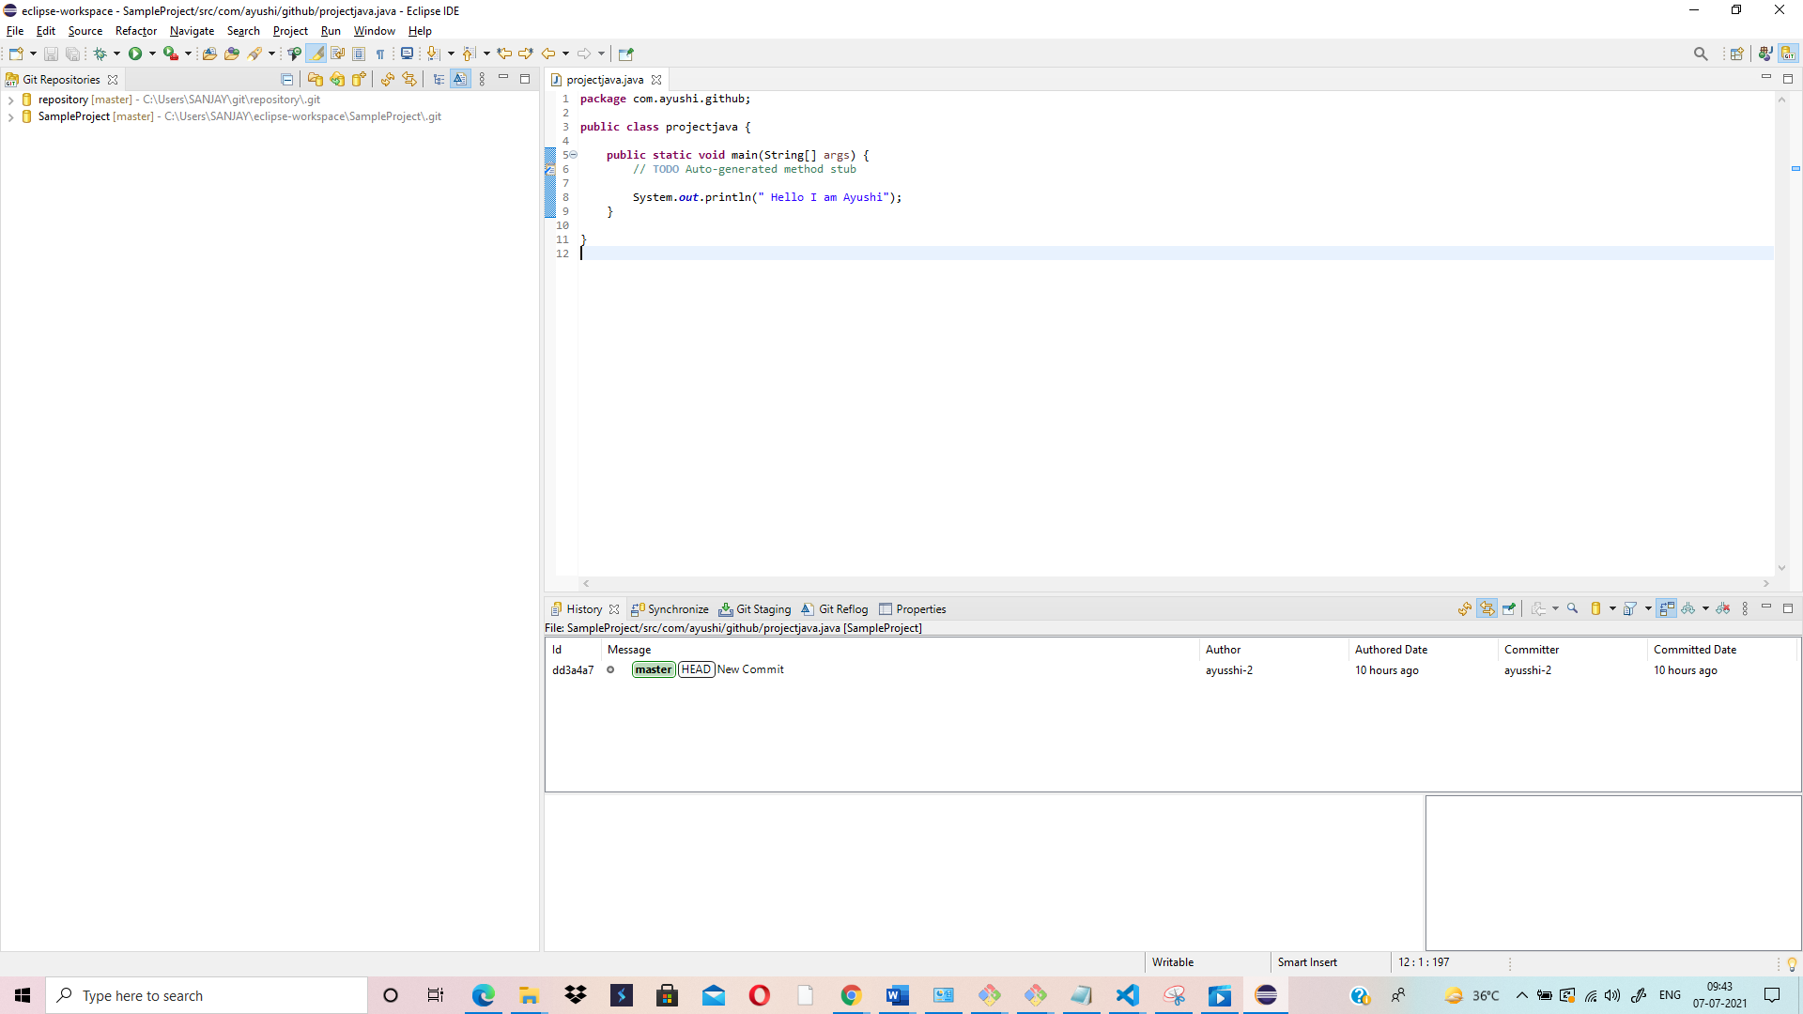

**Created private Repository “java-project” and pushed Java Sample Project onto it**

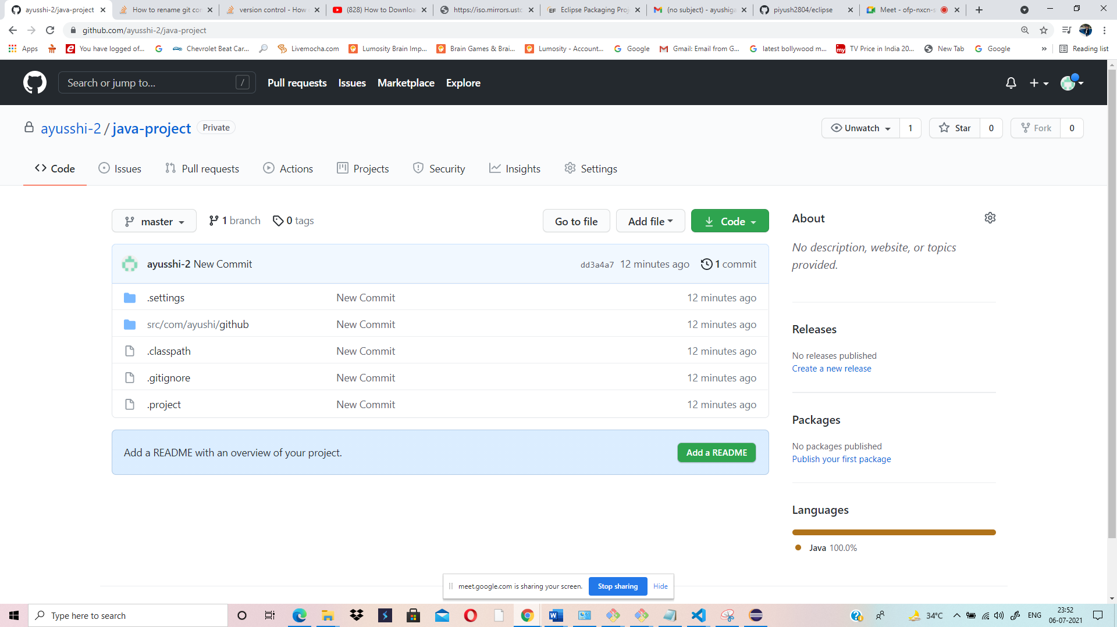

**Sent Invitation for Collaboration:**

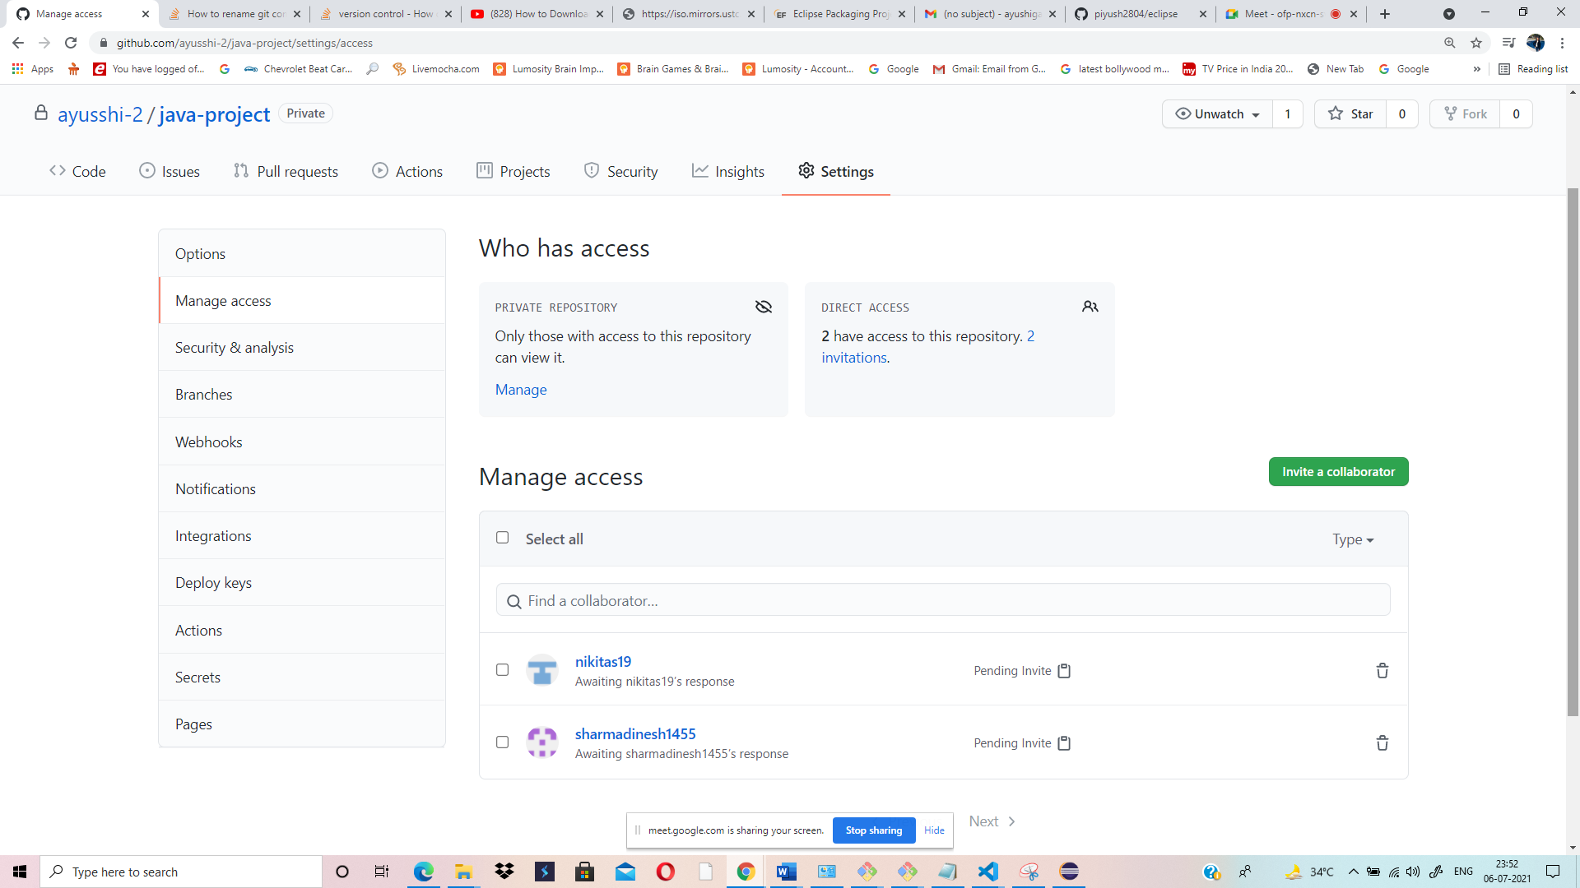

**Collaborating with Piyush to make changes in his Project:**

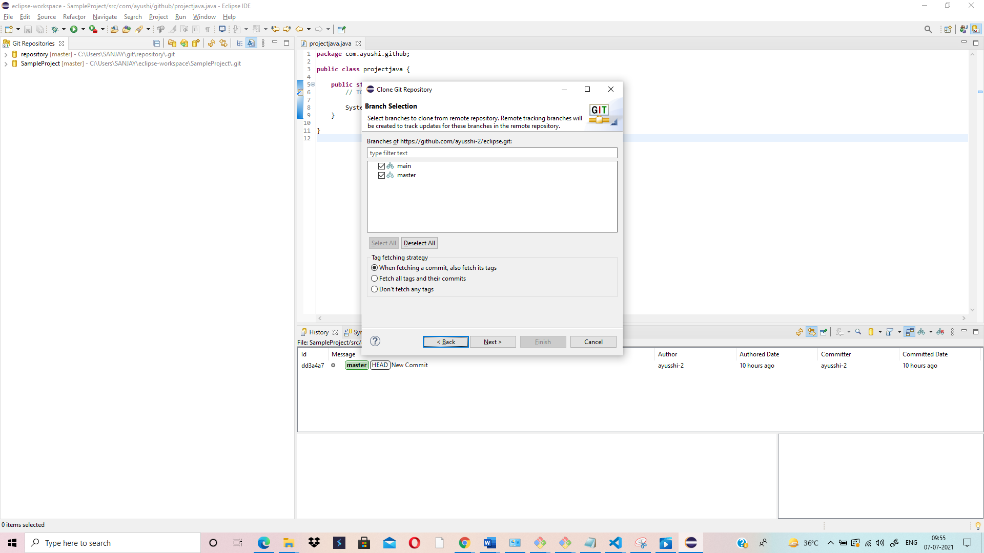

**Merge Pull Request Performed:**

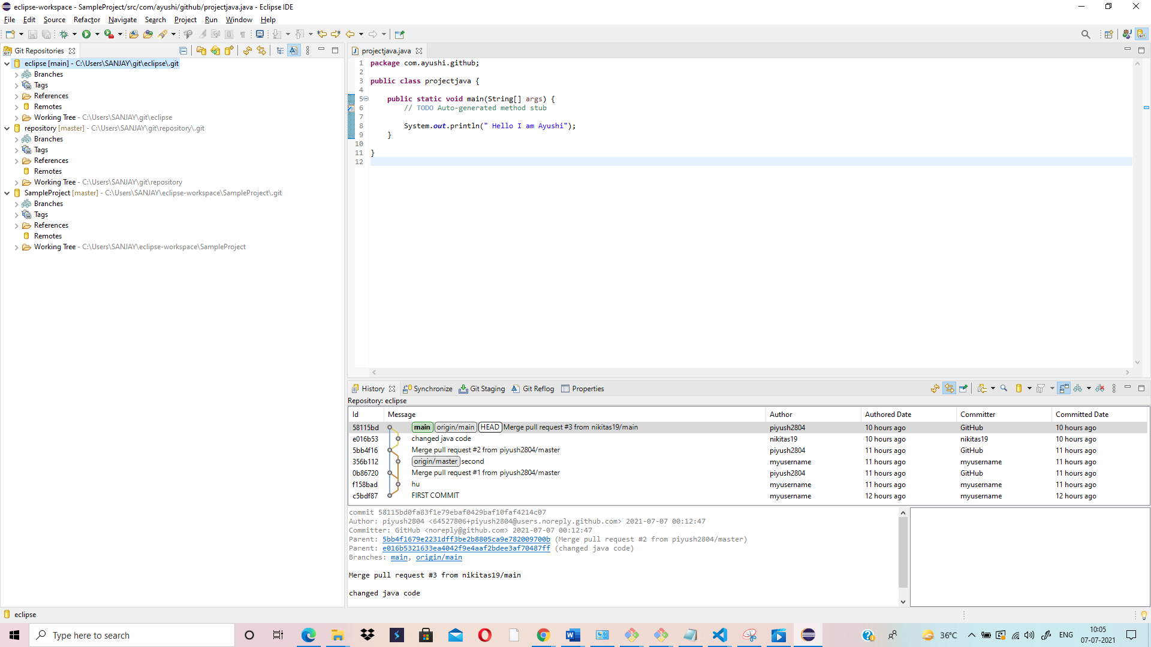

**Java Code Changed by me:**

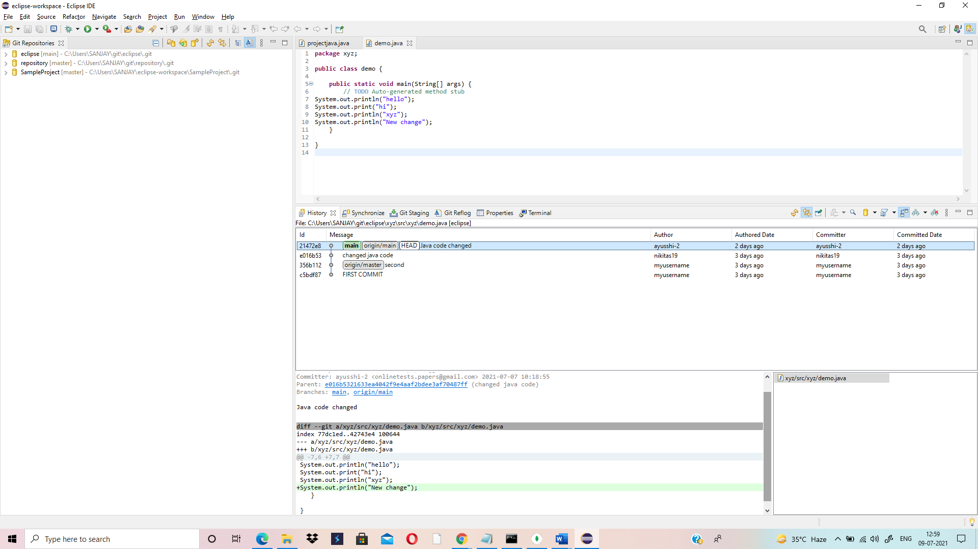

**Pushing the changes onto the Github Repository: (Performing Commit and Push Operations through terminal)**

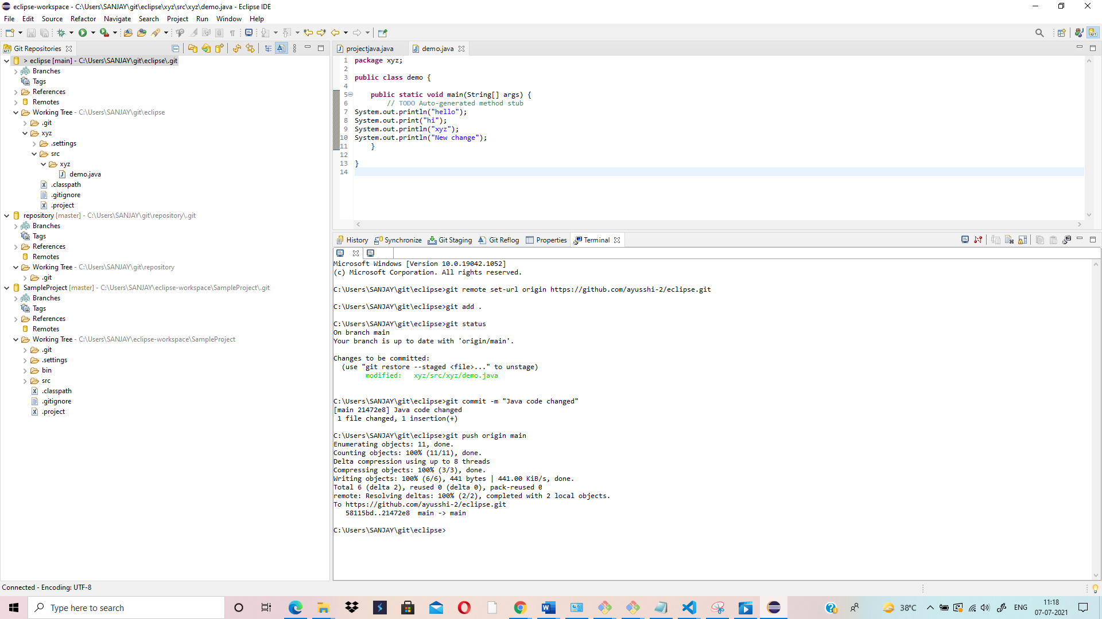

**Java Code Changed by me- (changes visible in my Repository)**

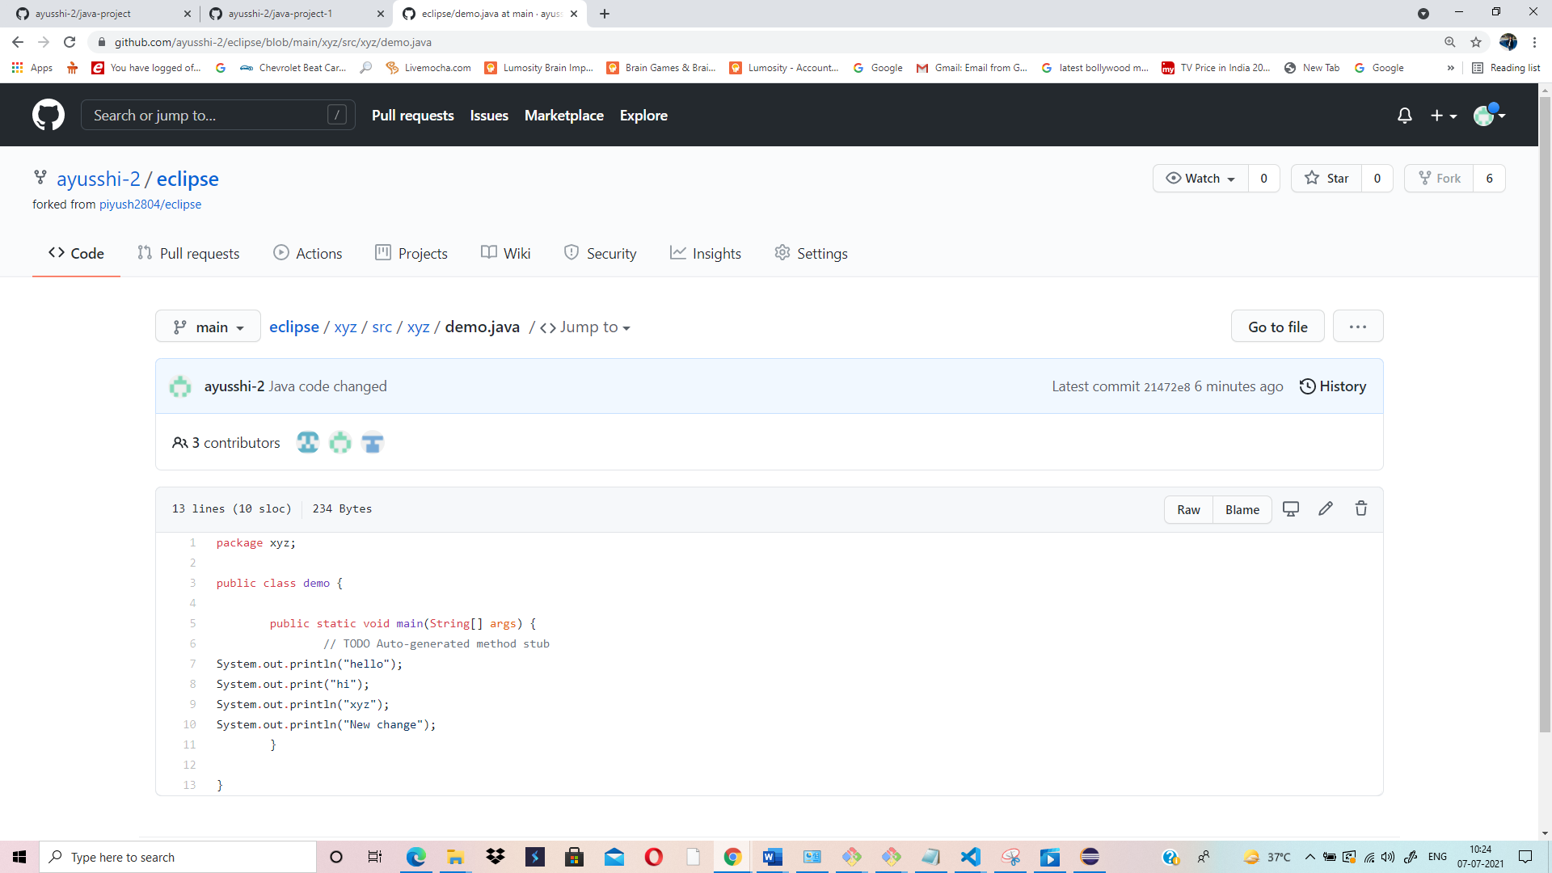

**Merge Failed due to Conflict:**

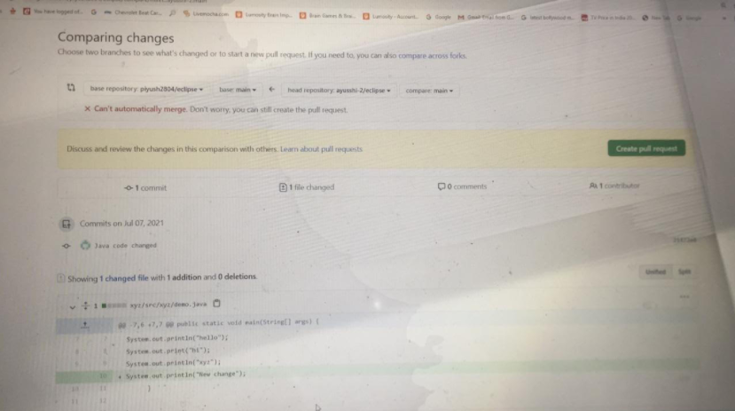

**Solved Conflict while merging manually-Sent Pull Request-Pull Request Accepted- Merged Successfully:**

